
Standard Operating Procedures for Local Boards of Health: Filing in Housing Court

If a Housing Case remains non-compliant and the time frames listed in the order to correct have expired (and no extension was granted from a Board of Health Hearing), an inspector may utilize housing court to assist in achieving compliance. Examples of difficult situations that may warrant filing in court may include but are not limited to:
- Owner refusing to make certain repairs.
- Timeframes in the original Correction Order have passed and no proof of work to correct violations has been received.
- The occupant is refusing to allow reasonable access for an inspector to conduct an inspection / re-inspection.
It is important to note that while all Housing Court locations across Massachusetts share the same forms and generally similar proceedings related to Housing cases, not all Courts conduct filing procedures the same way or may prefer certain filings to be done slightly differently than others. For this reason, it is strongly recommended that you contact the Housing Court serving your Municipality to better understand how they prefer filings to be completed to improve the efficiency of filing in court. Even though they are unable to provide legal advice on a case you are involved with, Housing Court staff may be able to discuss procedural questions related to the proper use of forms.

This document goes through the general filing process. It also includes information on Emergency Scenarios found on page 7.

- Before Filing in Housing Court:
- Review the housing case with your supervisor and determine if housing court is the next best step.
- Call your Housing Court to see if you can file the case – Some locations require a City Solicitor or Town Counsel to file your case. Other locations may allow the Health Department Staff to file themselves. Ask if you can file as a member of the Health Department, or if they require your Solicitor/Counsel to file your case.
    - Locations | Mass.gov - MA Housing Court Website to locate your Housing Court and its phone number.
  - If you can file yourself, it is recommended that you notify your City Solicitor/Town Counsel that you are doing so. That way, if the case progresses further to a point where you need them, they are in the loop already.
- When filing in Housing Court, you can file either a Civil or Criminal Complaint:
Civil complaints are typically the preferred route by most courts. These complaints typically move quicker and are useful for serious violations with short deadlines. Additionally, they allow for the use of Mediation to gain compliance. The Health Department must serve the responsible party with notice about the hearing and provide proof of service to the court before the first court appearance (this is covered in more detail in Section 5: “After you have filed”).
Criminal complaints result in harsher penalties on the responsible party and typically go directly in front of a judge or clerk magistrate. This type of complaint may be required for specific violations (i.e. Lead Paint violations). You may also convert a criminal case into a civil case once you appear in court. Criminal complaints typically take longer for you to get a court date, but the Court will provide the service for the court date to you and the party responsible for making repairs.
If you are unsure of what type of filing is preferred by your Court – call them!
- When filing a Civil Complaint, you will use both of the two forms below.
  - The first form is a “Civil Complaint”.
    - In this form you will describe the details of your case in the “Statement of Material Facts” section (think dates; date of the Inspection, Order to Correct, service of order and when the timeframes expired). Skip the “counts” section and complete the “Prayers for Relief” section with what you want the Court to do (Enforce the Order to Correct and have the owner make all the repairs).
    - Wait to sign this form until you are at the housing court with whoever you are filing with.
    - See Appendix A for a Sample of the Civil Complaint form.
  - The second form you will use is a “Motion form”. In the “Other” section of the Motion form you can write “Motion to enforce the State Sanitary Code – 105 CMR 410.000 Minimum Standards of Fitness...” or “See Civil Complaint form”.
    - See Appendix F for a Sample Motion form for Filing a Civil Case
- If filing a Criminal Complaint - A “Request for Criminal Complaint for Sanitary Code Violations” document must be completed.
  - Wait to sign this form until you are at the housing court with whoever you are filing with.
  - See Appendix B for a Sample Criminal Complaint Form – you can copy and paste this info and then fill in where applicable. Your housing court may also have a Criminal Complaint form that you can use – if that is the case, use the form provided by the Housing Court.
- If you are filing against the Owner, you must complete the form of your choosing for just the Owner. If you file against the Occupant, you must file against BOTH the Owner and Occupant and therefore file two separate forms.
  - You may also file against the Owner, and the Owner can then file against the occupant or request they appear at the Court date. Clarifying which approach is preferred with the Housing Court is strongly recommended.
- Gather ALL relevant documents before filing. This should include:
- The completed and unsigned Civil or Criminal complaint form you are filing
- A copy of the Correction Order and any subsequent orders or letters
- A copy of the Certified Mail receipts OR other proof of service
  - I.e. constable return of service documentation, or proof showing proper service of orders in accordance with 105 CMR 410.680(B).
- A summary of the Case Notes
  - This is a summary of events to give context to the case. Be detailed and include dates of the initial inspection, re-inspections and their results, and notes on or copies (i.e. emails) of correspondence with the Owner and/or Occupant.
  - The goal of your summary is to provide an overview of the case up to this point to show why you are filing, what violations remain uncorrected, and also help the court understand your efforts to remedy the violations and work with the property owner before you filed in court.
  - A sample Case Notes document can be found in Appendix C.
- Photos taken during the initial inspection and any re-inspection(s) showing violations cited.
- Any documents related to the Housing Case that may include but are not limited to:
- Pest Control Reports
- Police Reports
- Emails/written correspondence (i.e. texts, letters, etc.)
- Images received from the Owner or Occupant
- Correspondence or Letters from other Departments such as Building, Fire, etc.
  - For example, if the Owner needs a building permit for a repair but the Building Dept. confirms in an email no permit exists – include this email!
Once all paperwork and relevant documents are gathered, it may be beneficial to call the Court to ensure the Clerk Magistrate or Assistant Clerk Magistrate will be available to assist you in filing the case. Depending on availability, or the staffing in the Court, these individuals may be temporarily unavailable due to being in court, on vacation, or out sick.
- If the Clerk Magistrate or Assistant Clerk Magistrate is not available – ask when they will be or ask if anyone else is available to file your case.
- Going to Housing Court
- Before driving over - review your timeline of events in case the Housing Court has any questions on the information you are submitting. Ensure all paperwork is accurate and nothing is missing.
- Proceed to the Housing Court and ask to file your case. The Clerk Magistrate or Assistant Clerk Magistrate will review your paperwork and swear you in. If you file a civil complaint, an individual at Housing Court’s front desk may be able to take your documentation. In either case, the person assisting you will provide a date and time-stamped copy of the form you are filing for your records.
- Whenever possible - bring a copy of all items being submitted to the court (i.e. all items listed under Section 3). The individual you file with typically will make copies of your documentation, however bringing an extra set for them will expedite the process and can help build a rapport with the Court. It also allows you to know exactly what you gave to the court when you filed.
- After you have filed:
  - If you filed a Civil Complaint – You are responsible for notifying parties via proper service. The court will provide you with the documents you need to serve upon the party you are filing against (i.e. the Owner and/or Occupant).
    - It is recommended to do this service via constable or sheriff as you will need to provide proof of service before the first court date (i.e. you are showing the court that the Owner was served notice of the complaint filed against them, which includes the date of the Court appearance they will attend). Once the constable gives you the proof of service, get it to the Court as soon as possible.
    - The documents provided to you by the Court will have a date and time for the initial hearing. Make sure you block this off on your calendar.
  - If you filed a Criminal Complaint – The Court will notify parties of a hearing date. This is typically done via mail and may take some time to receive, and you are not required to do anything in this instance after you file. Once you receive notice from the Court, make sure to block the date off on your calendar.

- Remember that filing in Court is not the final step of enforcement
- Before the Court date – it is advisable to conduct a reinspection as close to the court date as possible. The same day as your court date is ideal, or the afternoon before your court date, but otherwise as close to the court date as possible.
  - Take updated pictures and document results of the re-inspection – be as detailed as possible regarding re-inspection notes.
- If all violations are corrected and re-inspected before the court date – you may choose to dismiss the filing.
  - This can be done by completing a Motion form and selecting “Dismiss this case”. In the description, note “all violations of 105 CMR 410.000 in the Correction Order dated __________ have been re-inspected and were observed to have been corrected at this time.”
- When appearing for your Court date:
  - Review all documents beforehand to familiarize yourself with the case and any recent updates (i.e. reinspection results, documents from the owner).
  - Be professional – arrive early, dress professional, investigate the court’s rules ahead of time (i.e. are electronic devices allowed inside the courthouse, proper identification, etc.)
  - Make sure you know what you want to ask of the Court. During the hearing, the Court will ask what it is you want to achieve with your filing.
    - Identify the most pressing violations and request these be addressed first and addressed as soon as possible.
      - Have an idea of when you would like to appear in court again in case you are asked. For example, is appearing again in 3 weeks for a status hearing on these repairs acceptable to you? Would you prefer 1 week or 2 weeks instead? Will you be able to conduct a re-inspection within that time period?
    - Write down any other requests you would like to propose to the Court. This could include agreements between you and the owner, or between parties if both the owner and occupant are present.
      - I.e. The owner agrees to have a building permit application submitted for repairs to be made by X date…
Emergency Scenarios
In an emergency scenario (think – a condition making a unit unfit for human habitation), a Temporary Restraining Order (TRO) may be able to be utilized to help get a court order to relocate the occupant. It is strongly recommended that, in this scenario, the inspector write up a report or summary of their report and give it to the occupant, and that the occupant go to court to pursue a TRO. This is for two reasons;
- The occupant can represent themselves (called “pro-se” - acting on one’s own behalf) and the Court can help walk them through the process of getting a TRO.
- Filing a TRO may be viewed as “practicing law” by the court, and to practice law you must be an attorney. This may mean that a municipal attorney will need to file the TRO, which may slow down the process as the inspector would need to contact the attorney, inform them of the case details, and get the document filed.
In an emergency scenario, time is of the essence, which is why we recommend the occupant pursue a TRO. If they are unable to, or unwilling to, then the inspector should contact their attorney to help file this document. Typically, a Motion Form or Statement of Material Facts form accompanies the TRO. The TRO can be filed with injunctive relief, whether preliminary or permanent.
- Injunctive relief is a court ordered remedy to restrain a party from certain acts, or to require a party to act in a certain way. For example, require a party to turn utilities back on to the unit, or require the occupant to be relocated from the unit deemed unfit for human habitation.
The Judge may then consider additional options like:
- Ordering tenancy preservation.
- Having the property go into receivership.
- Order the Owner to put tenants up in alternative housing.
- Issue guardianship over someone if found not to be of sound mind.
These forms can be found at: https://www.mass.gov/lists/housing-court-forms
- A sample “Statement of Material Facts” form can be found in Appendix D
- A sample “Temporary Restraining Order” for Emergency Relocation of an Occupant can be found in Appendix E
Congrats! You have successfully filed in Housing Court.
APPENDIX A: SAMPLE CIVIL COMPLAINT FORM
Civil Complaint Form Link https://courtforms.jud.state.ma.us/content/dam/formsanddocuments/publicforms/HC0019.xdp/jcr:content

APPENDIX B: SAMPLE CRIMINAL COMPLAINT FORM
This can be copy & pasted into a word document and then completed.
REQUEST FOR CRIMINAL COMPLAINT
FOR STATE SANITARY CODE VIOLATIONS

To any Justice or Clerk Magistrate of the Northeast Housing Court:
[Insert your name, title and municipality] __________________________________________
on behalf of the Commonwealth, on oath complains that:
[Property Owner Name] ________________________________________________________
was and is the owner of residential premises located at:
[Address where Violations Cited]_________________________________________________

On [Date of Initial Inspection], [Year], a representative of the
[Insert your organization – I.e. Town/City Health Department] Program inspected the said premises and determined that the dwelling did not comply with the provisions of Article II of the State Sanitary Code, 105 C.M.R. §410.000;

On [Date Correction Order was Received by Owner], [Year], pursuant to §410.670-680 of the Code, the defendant was served with a written order to comply;

On [Date Violations were past due for Correction – Use correction order timeframes], [Year], and from day to day thereafter the defendant has failed to comply with the order, each such day being a separate offense and a separate and distinct count of this complaint;

all in violation of State Sanitary Code, 105 C.M.R. §410.910 -.920, and public health law, Gen.L. c.111 §127A, and the defendant did so willfully, intentionally, recklessly or repeatedly.
[Leave Blank] ________________ [Leave Blank] _____________________________
Date Complainant

Assigned for hearing on ____________________________, at ____________________o’clock

On hearing [Complaint] [Defendant] [both parties] [neither party], I find no probable cause for the complaint. Process shall not issue.

On hearing [Complaint] [Defendant] [both parties] [neither party], and Complainant having sworn or affirmed that the Complaint is true upon information and belief, I find probable cause, and order summons to issue returnable ___________________________________________.

__________________ _________________________________
Date Clerk Magistrate

Appendix C – SAMPLE TIMELINE OF EVENTS
Appendix D: SAMPLE STATEMENT OF MATERIAL FACTS FORM
Statement of Material Facts Link - https://courtforms.jud.state.ma.us/publicforms/HC0010
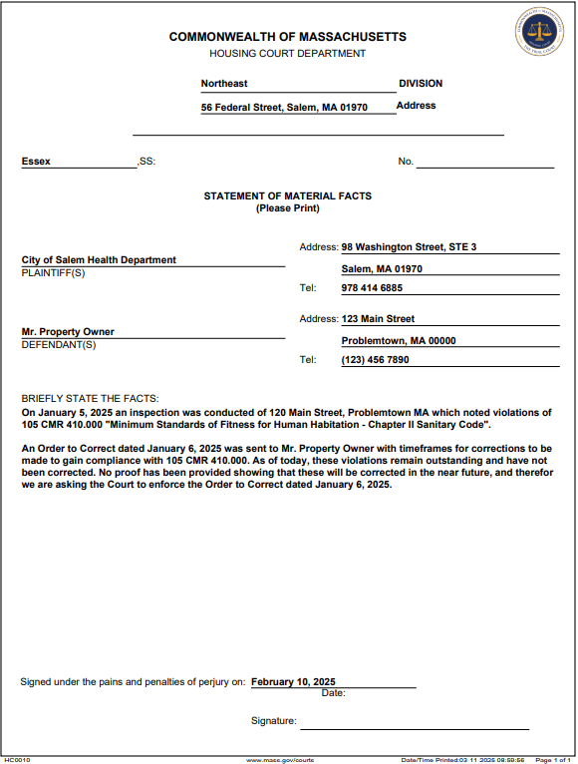

APPENDIX E: SAMPLE TEMPORARY RESTRATINING ORDER (TRO) FORM (FOR EMERGENCY RELOCATION OF OCCUPANT)
TRO Link - https://courtforms.jud.state.ma.us/publicforms/HC0004
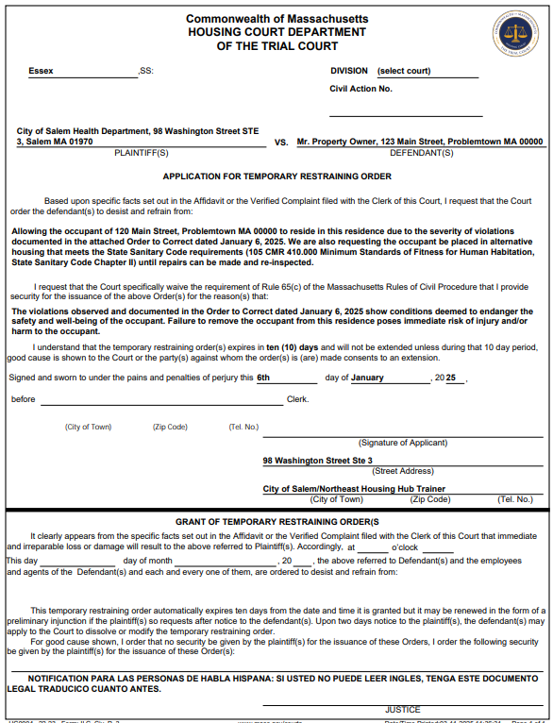
Appendix F: SAMPLE “MOTION” FORM FOR FILING CIVIL CASE
Motion Form Link - https://courtforms.jud.state.ma.us/publicforms/HC0007
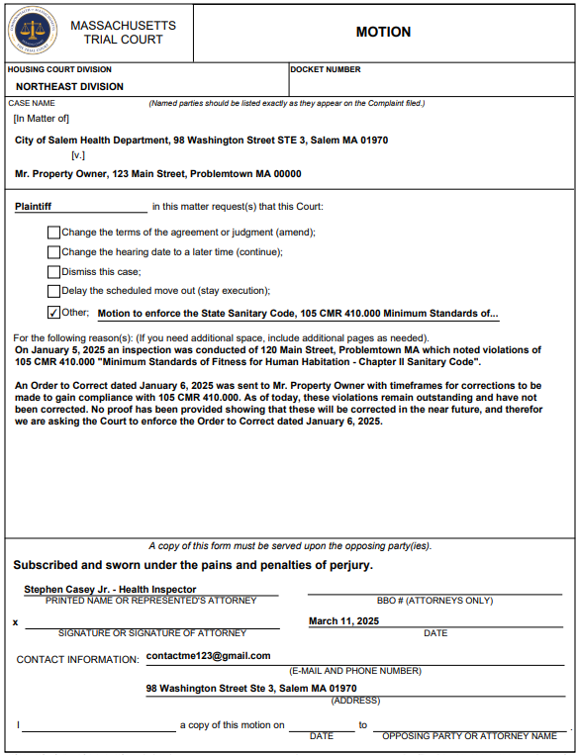
Northeast Public Health Training Hub - Housing Court Locations
- Northeast Housing Court – Salem Session
56 Federal Street, Salem MA 01970
(978) 825 4920 |Monday – Friday, 8:30am – 4:30pm
SERVES: Beverly, Danvers, Essex, Gloucester, Hamilton, Ipswich, Lynnfield, Manchester-by-The-Sea, Marblehead, Middleton, Peabody, Rockport, Salem, Swampscott, Topsfield, and Wenham.
- Northeast Housing Court – Lynn Session
56 Federal Street, Salem MA 01970
(978) 825 4920 | Monday – Friday, 8:30am-4:30pm
SERVES: Lynn, Nahant, and Saugus
- Northeast Housing Court – Woburn Session
200 Trade Center, Woburn MA 01801
(978) 656 7600 | Thursday 8:30am-4:30pm
SERVES: Bedford, Burlington, Concord, Everett, Lexington, Lincoln, Malden, Melrose, North Reading, Reading, Stoneham, Wakefield, Waltham, Watertown, Weston, Wilmington, Winchester, and Woburn.
- Eastern Housing Court – Middlesex Session
175 Fellsway, Somerville, MA 02145
(617) 788 8485 | Fridays 8:30am
SERVES: Arlington, Belmont, Cambridge, Medford, Newton, and Somerville.
- Northeast Housing Court – Lawrence Session
2 Appleton Street, 2nd Floor, Lawrence MA 01840
(978) 689 7833 | Monday – Friday, 8:30am-4:30pm
SERVES: Amesbury, Andover, Boxford, Georgetown, Groveland, Haverhill, Lawrence, Merrimac, Methuen, Newbury, Newburyport, North Andover, Rowley, Salisbury, and West Newbury.
As a note: If you need to file in Housing Court and it is outside of the day(s) listed on the Court’s website, there will typically be another Court that can assist you in filing. This could be a District Court or a different Housing Court location. It is recommended to call your Housing Court and see which other location you should utilize in this scenario.

Full Hyperlinks included throughout this document
Section 1: Locations of Housing Courts
https://www.mass.gov/orgs/housing-court/locations
Section 2: Civil Complaint Forms
Civil Complaint Form - https://courtforms.jud.state.ma.us/content/dam/formsanddocuments/publicforms/HC0019.xdp/jcr:content
Motion Form - https://courtforms.jud.state.ma.us/publicforms/HC0007

Section 3: All Housing Forms - https://www.mass.gov/lists/housing-court-forms

